SLIMCD Recurring Web Service Interface Specification

API Programmers Manual Release 1.0 05/13/2014 Zeyuan Wu

Introduction
This document describes the Programmer’s API for the SLIMCD Recurring Web Service Specification with pseudo code.
The web service allows a programmer to setup and update Credit Card and Check recurrings, to list all recurrings and get all transactions for a specific recurring id.
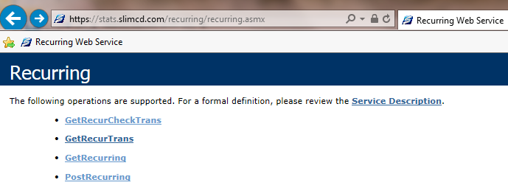
XML element | Format, name | Value
recurid | int, recurring ID | -1: to get recur or transaction count  0: to create a new recurring  >0: to update a recurring
clientid | int, client ID | 1032 e.g.
password | char(50), password
siteid | int, site ID | 228226448 e.g.
priceid | int, price ID | 74 e.g.
ticket | int, Gate ID | 59723423 e.g.
rebillamt | money, rebill amount | 10.01 e.g.
numofpayments | int, number of payments | 0 for infinite recurring
startmonthyear | int, start month year in MMYY | 0615 e.g.
expdate | char(4), expire date in MMYY; or processor & check type(P-personal, B-business, C-checking, S-saving) | 1249 e.g. for credit card or  ACHP e.g. for check
active | bit, recurring active indicator | 1-active; 0-inactive
clientip | char(15) | 192.168.0.102 e.g.
rebillcycle | char(1), rebill cycle | M – monthly; O – One time; W – weekly; B – bi-weekly; T – twice a month; Q – quarterly; S – semi-annually; Y – yearly
rebillmonth | int, rebill month | 0 for rebill cycle M/W/B/T  1-3 for rebill cycle Q  1-6 for rebill cycle S  1-12 for rebill cycle O/Y
rebillday | int, rebill day | 1-7, 1 is Monday if rebill cycle W/B  1-30 for rebill cycle M/O/T/Q/S/Y
invoice | char(4), invoice number
datetime | char(12), date | MM/DD/YYYY
approved | char(1), status of transaction | A - all, Y - approved, N - declined
first4digits | 4 digits for credit card only | to narrow down recurring search
responsecode | count of recurring or transactions | In the response of web service

- Setup a new recurring by supplying <recurid>0</recurid>
URL = “https://stats.slimcd.com/recurring/recurring.asmx/PostRecurring”
PostData = "XMLRecurPost=<request><recurid>0</recurid><clientid>1032</clientid>
<password>289075</password><siteid>228226448</siteid><priceid>74</priceid>
<ticket>59723423</ticket><rebillamt>12</rebillamt><numofpayments>0</numofpayments>
<startmonthyear>0614</startmonthyear><expdate>1249</expdate><active>1</active>
<clientip> 192.168.0.102</clientip><rebillcycle>M</rebillcycle><rebillmonth>0</rebillmonth>
<rebillday>5</rebillday><invoice>1234</invoice></request>”
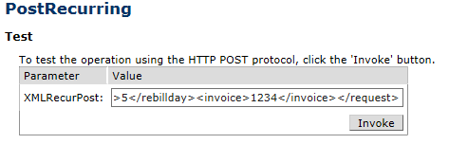
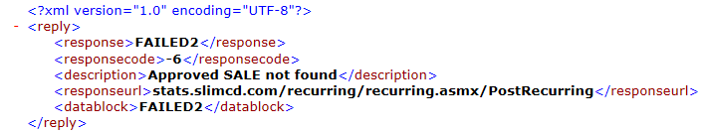
- Update a recurring by supplying none-zero <recurid>
URL = https://stats.slimcd.com/recurring/recurring.asmx/PostRecurring

PostData = "XMLRecurPost=<request><recurid>56032</recurid><clientid>1032</clientid>
<password>289075</password><siteid>228226448</siteid><priceid>74</priceid>
<ticket>102363295</ticket><rebillamt>50.00</rebillamt><numofpayments>0</numofpayments>
<startmonthyear>0514</startmonthyear><expdate>1249</expdate><active>1</active>
<clientip> 192.168.0.102</clientip><rebillcycle>M</rebillcycle><rebillmonth>0</rebillmonth>
<rebillday>8</rebillday><invoice></invoice></request>”
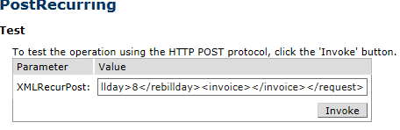
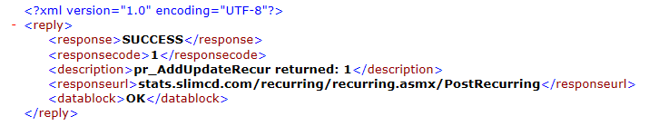
- Deactivate/re-activate a recurring
URL = “https://stats.slimcd.com/recurring/recurring.asmx/PostRecurring”
To deactivate: <active>0</active>
To re-activate: <active>1</active>

PostData = "XMLRecurPost=<request><recurid>29024</recurid><clientid>1032</clientid>
<password>289075</password><siteid>228226448</siteid><priceid>74</priceid>
<ticket>52705987</ticket><rebillamt>15.97</rebillamt><numofpayments>0</numofpayments><startmonthyear>0514</startmonthyear><expdate>1249</expdate><active>0</active>
<clientip> 192.168.0.102</clientip><rebillcycle>M</rebillcycle><rebillmonth>0</rebillmonth>
<rebillday>8</rebillday><invoice></invoice></request>”
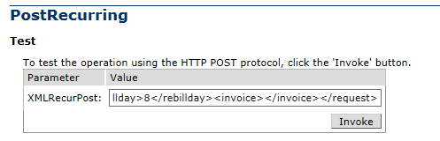
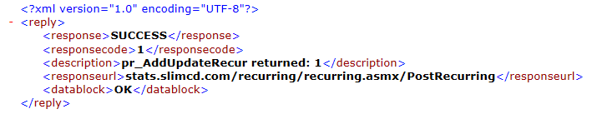
- Get total active or inactive recurring count by supplying -1 for startrecurid
URL= “https://stats.slimcd.com/recurring/recurring.asmx/GetRecurring”
PostData = "XMLRecurGet=<request><startrecurid>-1</startrecurid><clientid>1032</clientid>
<password>289075</password><siteid>228226448</siteid><active>1</active></request>"

OpenURL (URL, Method, Headers, PostData)
In the response, the element < responsecode > is total recurring count for the specified clientid, siteid and active.

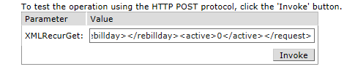
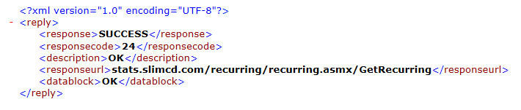
You can paste <request>….</request> with <active>0</active> to get total inactive recurrings.

- Get recurring list details by supplying <startrecurid>, you get 50 recurring only one at a time with <startrecurid> inclusive , you can supplying the first 4 digits and/or rebill day to narrow down the list.
URL= “https://stats.slimcd.com/recurring/recurring.asmx/GetRecurring”

PostData = "XMLRecurGet=<request><startrecurid>0</startrecurid><clientid>1032</clientid>
<password>289075</password><siteid>228226448</siteid><first4digits></first4digits>
<rebillday></rebillday><active>1</active></request>"
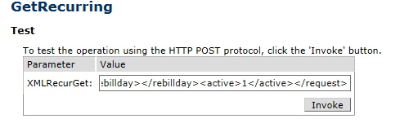
Note:<first4digits> for credit card only, not for check.
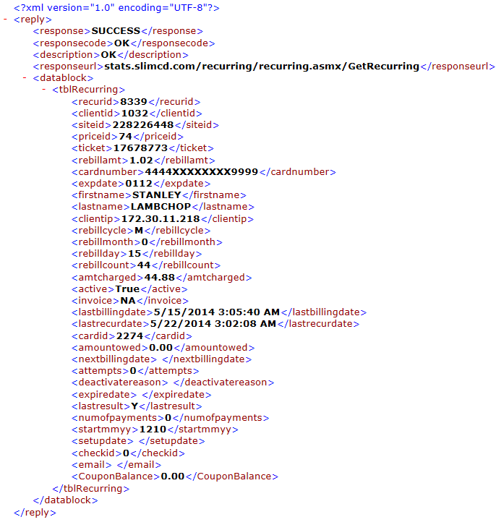

- Get total transaction count for specific cardid by supplying -1 for <startgateid>
URL = “https://stats.slimcd.com/recurring/recurring.asmx/GetRecurTrans”

By supplying different value of element <approved>, you get different total count: ‘A’ for all, ‘Y’ for approved only, ‘N’ for declined. In the response, the element < responsecode > is total transaction count.

PostData = "XMLRecurTrans=<request><startgateid>-1</startgateid><cardid>11959</cardid>
<clientid>1032</clientid><password>289075</password><siteid>228226448</siteid>
<datetime></datetime><approved>A</approved></request>"
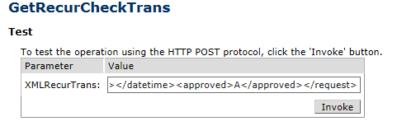
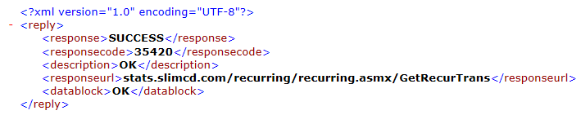
For checks, replace <cardid> by <checkid>, and use web service GetRecurCheckTrans instead.

- Get recurring transactions list for specific <cardid> by supplying <startgateid>, you get 50 transactions only one at a time with < startgateid > inclusive, you can supplying <datetime> format as mm/dd/yyyy to narrow down a single day.

URL = “https://stats.slimcd.com/recurring/recurring.asmx/GetRecurTrans”

By supplying different value of element <approved>, you get different total count: ‘A’ for all, ‘Y’ for approved only, ‘N’ for declined. In the response, the element < responsecode > is total transaction count.

PostData = "XMLRecurTrans=<request><startgateid>0</startgateid><cardid>11959</cardid>
<clientid>1032</clientid><password>289075</password><siteid>228226448</siteid>
<datetime>8/19/2011</datetime><approved>A</approved></request>"
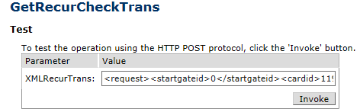

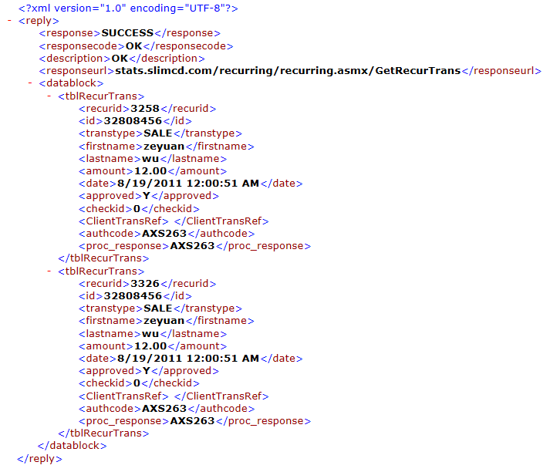
For checks, replace <cardid> by <checkid>, and use web service GetRecurCheckTrans instead.

- Work on coupon balance
Include <CouponBalance>12</CouponBalance><CouponAction>sub</CouponAction>
within <request></request> to work on coupon balance, <CouponAction> can be either SET to set a coupon balance, ADD to add coupon balance or SUB to subtraction coupon balance.
When you work on coupon, the web service will ignore other parameters. Leave <CouponAction> blank if you want update other recurring parameters.

These XML elements are required to work on coupon balance:
<request><recurid>101</recurid><clientid>1111</clientid><password>visa123</password><siteid>249949344</siteid><priceid>149</priceid><ticket>64802276</ticket><CouponBalance>1</CouponBalance><CouponAction>SUB</CouponAction></request>

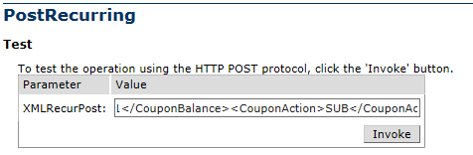

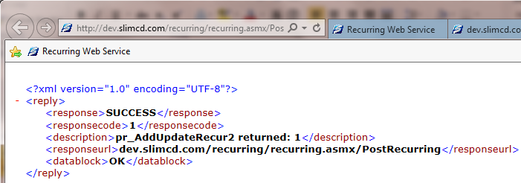

Error code | Description
-1 | get DESEXP failed or missing gateid.
-2 | get CARDID failed.
-3 | get CARDNUMBER failed.
-4 | Failed Ticket# WAS in recurring.
-5 | Failed CARDNUMBER WAS in recurring.RecurID=
-6 | Approved SALE not found.
-7 | tblRecurring insert failed.
-8 | tblRecurring update failed.
-9 | Number of pays must be greater than number rebilled.
-10 | Invalid Start Month Year mmyy.

